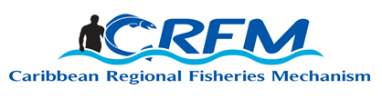
PRESS RELEASE

FOR IMMEDIATE RELEASE

PRESS CONTACT NAME: Milton Haughton, Executive Director PHONE: 501-223-4443
E-mail: milton.haughton@crfm.int

CRFM Fisheries Ministers address Small-scale Fisheries and blue economy matters at 12th Special Meeting

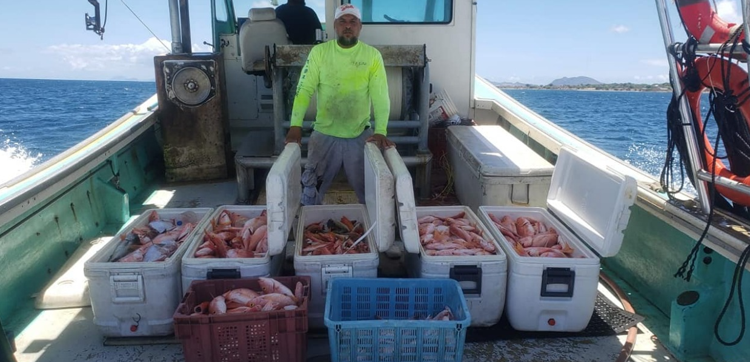
Photo courtesy CNFO - Fisher in Saint Kitts and Nevis
Belize City, Wednesday, 12 October 2022 (CRFM)—The Ministerial Council of the Caribbean Regional Fisheries Mechanism (CRFM) held its 12th Special Meeting on Friday, 7 October 2022. The Council of Ministers, which is the chief policy and decision-making body of the CRFM, passed a series of resolutions to address key issues that affect sustainable use and management of the fisheries and aquaculture sectors, and to strengthen the governance and administration of the CRFM.
During its 12th Special Meeting, the Ministerial Council passed a resolution on positioning small-scale fisheries and aquaculture in the CARICOM regional blue economy dialogue and policies. The Council thereby approved a policy document aimed at improving and role of Small-scale Fisheries and Aquaculture in the Regional Blue Economy Dialogue. The document reflects the aspirations and ideals of the small-scale fishing communities and reaffirms the critical role of fisheries, and especially small-scale fisheries and aquaculture, in regional food security and nutrition, livelihoods, poverty eradication, trade, and contributing to blue economic growth in the region.
The Fisheries Ministers expressed their commitment to collaborating with all actors to create enabling conditions, implement targeted interventions and mainstream the inclusion of small-scale fisheries and aquaculture in the blue economy at the national and regional levels.
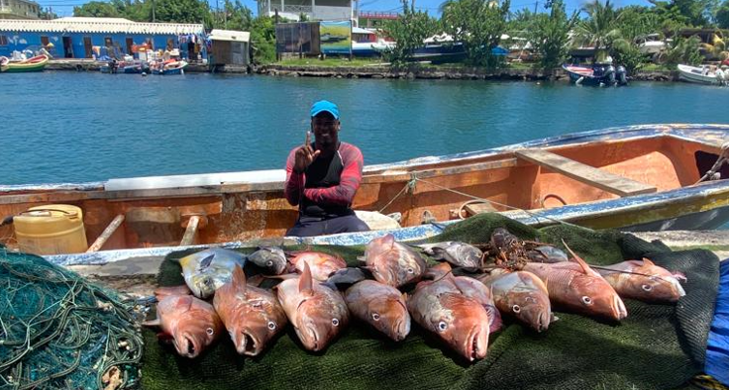
Photo courtesy CNFO - Fisher in Saint Lucia
The Council called upon CRFM Member States and all actors to utilize the CRFM guidance document in crafting policies, programmes, and plans to highlight the importance of small-scale fisheries and aquaculture to the blue economy. It furthermore urged Member States to promote and support small-scale fisheries and aquaculture in the post-pandemic reconstruction of the countries to improve economic, social, and environmental resilience and self-reliance, and promote food security, safe and decent work, and the eradication of poverty in the region.
The Council also passed a resolution adopting the CNFO/CRFM Small-scale Fisheries Action Plan 2023-2025: Contributing to Achieving the 25% Reduction in the Caribbean Community Food Import Bill by 2025, developed through a collaborative effort between the Caribbean Network of Fisherfolk Organizations (CNFO) representing the interests of small-scale fisherfolk in the Caribbean, and the CRFM.
The CRFM Ministerial Council also recognized the critical role of national fisherfolk organisations (NFOs) and other stakeholders in ensuring the successful implementation of the CNFO/CRFM Small-scale Fisheries Action Plan 2023-2025. It, therefore, called upon the Caribbean fisherfolk, and regional and international development partners, donors, private sector and community-based organisations to prioritize the implementation of the Action Plan, in collaboration with the CRFM Secretariat, to address the challenges of increasing fish and seafood production and availability in a sustainable manner while contributing to reducing the regional food import bill by 25% by 2025.
The Council urged the CNFO and the small-scale fisherfolk in the region to work along with the CRFM and the respective national authorities and institutions to enhance engagement across all CRFM Member States, and to utilize the CNFO Leadership Institute and communications tools to help bolster inclusion of fisherfolk at the national level.
The CRFM Ministerial Council passed a total of eight (8) resolutions during the 12th Special Meeting. Two key policies approved by the CRFM Ministerial Council are the CRFM Anti-Bribery and Anti-Corruption Policy 2022 and the CRFM Personal Data Protection Policy 2022.
The Council passed a resolution approving the celebration of the CRFM’s 20th Anniversary starting January 2023, and issued a statement on the celebrations, which will showcase the vital contributions of fisheries and aquaculture to the regional and national economies, and to food and nutrition security, livelihoods, job creation, trade, and blue economic growth.
Finally, the Council passed a resolution addressing the proposals to list 91 species of fish and other marine living organisms on CITES Appendices I or II at the upcoming Conference of Parties of the Convention on International Trade in Endangered Species of Wild Fauna and Flora (CITES) in November 2022.

- ENDS -

ABOUT THE CRFM:

The Caribbean Regional Fisheries Mechanism (CRFM) was officially inaugurated on 27 March 2003 in Belize City, Belize, where it is headquartered, following the signing of the “Agreement Establishing the CRFM” on 4 February 2002. It is an inter-governmental organization whose mission is “to promote and facilitate the responsible utilization of the region's fisheries and other aquatic resources for the economic and social benefits of the current and future population of the region.”
CRFM social media links:
YouTube: http://www.youtube.com/user/TheCRFM
Facebook: http://www.facebook.com/CarFisheries
Twitter: https://twitter.com/CaribFisheries

